**3. Import data from CSV file ’IPL_matches.csv’ attached in resources to ‘matches’**

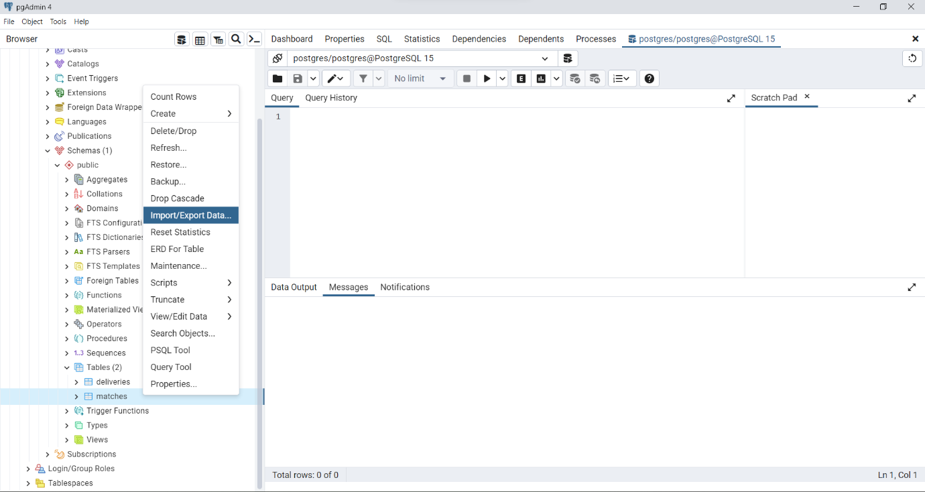

**4. Import data from CSV file ’IPL_Ball.csv’ attached in resources to ‘deliveries’**



